Hasil Index.html
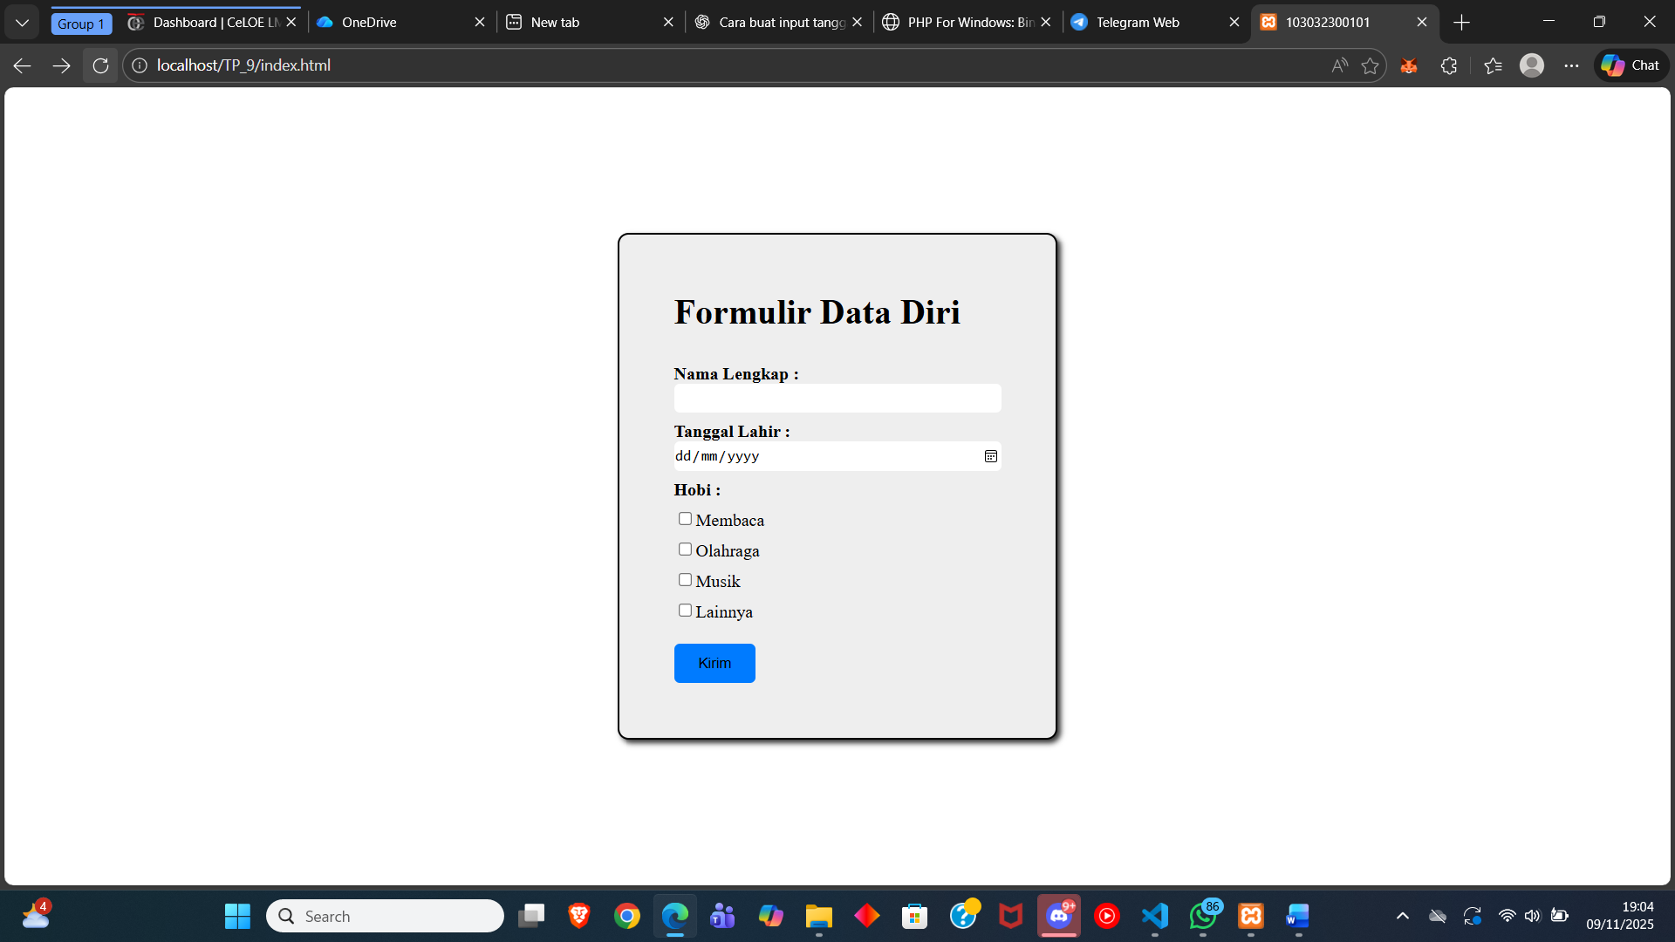
Saat mengisi data
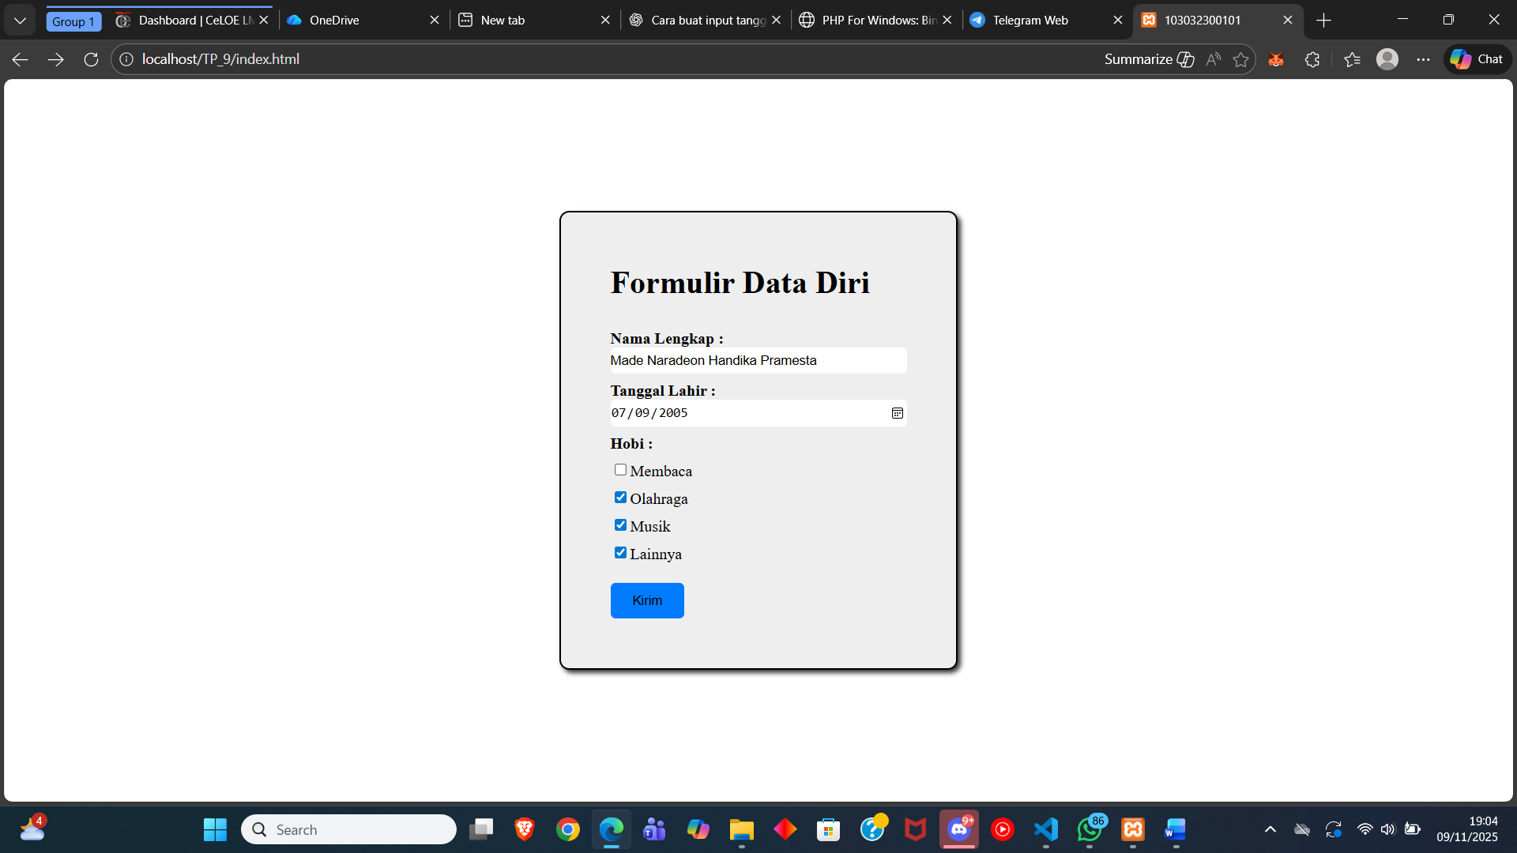
Saat tombol kirim di klik
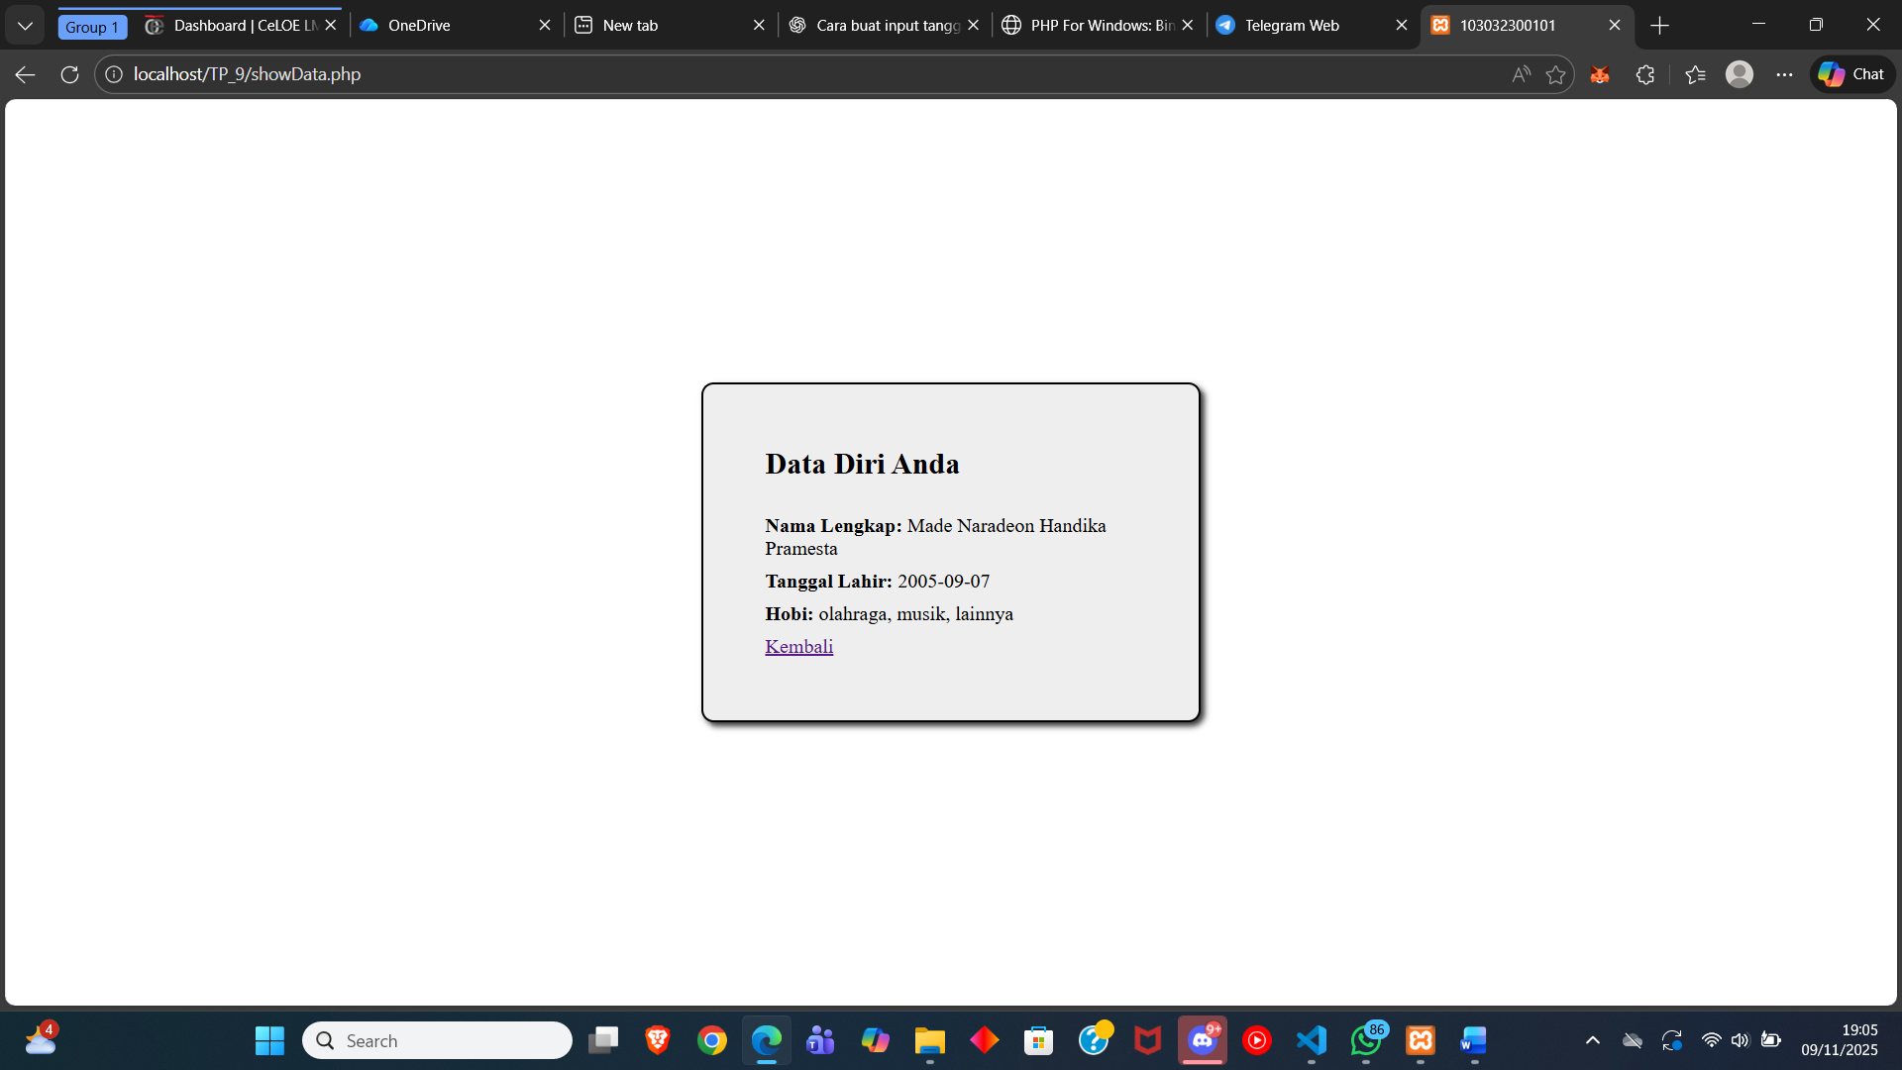
Tombol Kembali di klik
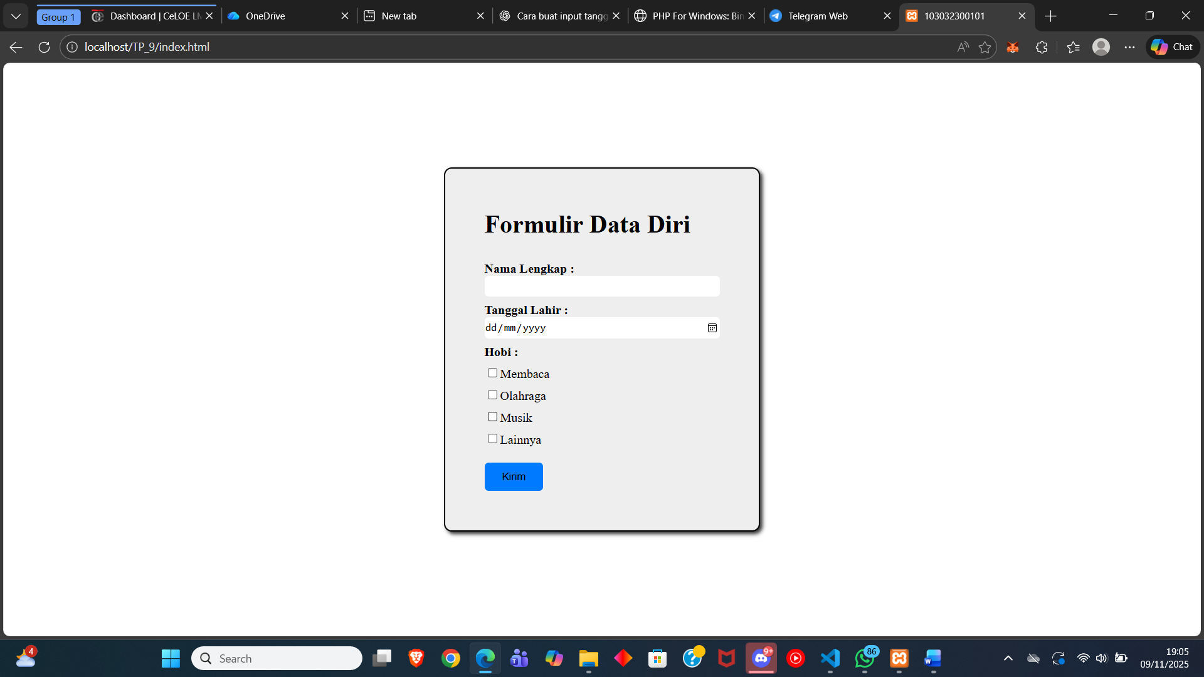

Index.html

<!DOCTYPE html>
<html lang="en">
<head>
<meta charset="UTF-8" />
<meta name="viewport" content="width=device-width, initial-scale=1.0" />
<title>103032300101</title>
<link rel="stylesheet" href="style.css" />
</head>
<body>
<div class="container">
<form action="showData.php" method="post">
<h1>Formulir Data Diri</h1>
<label><b>Nama Lengkap :</b></label>
<input class="text" name="nama" type="text" />

<label><b>Tanggal Lahir :</b></label>
<input class="text" name="tgl_lahir" type="date" />

<label><b>Hobi :</b></label>
<label
><input type="checkbox" name="hobi[]" value="membaca" />Membaca</label
>
<label
><input
type="checkbox"
name="hobi[]"
value="olahraga"
/>Olahraga</label
>
<label
><input type="checkbox" name="hobi[]" value="musik" />Musik</label
>
<label
><input type="checkbox" name="hobi[]" value="lainnya" />Lainnya</label
>

<button name="kirim">Kirim</button>
</form>
</div>
</body>
</html>

Style.css
body {
margin: 0;
padding: 0;
box-sizing: border-box;
display: flex;
justify-content: center;
align-items: center;
height: 100vh;
}

.container {
background-color: #eee;
border: 2px solid #000;
width: 400px;
border-radius: 10px;
box-shadow: 3px 3px 5px rgba(0, 0, 0, 0.8);
}

form {
display: flex;
flex-direction: column;
justify-content: center;
padding: 30px 50px 50px;
}

form label {
padding: 8px 0 0;
}

.text {
width: 100%;
padding: 5px 0;
border-radius: 5px;
border: #ccc;
outline: none;
}

button {
width: 75px;
padding: 10px;
margin: 20px 0 0;
background-color: #007bff;
border-radius: 5px;
border: #ccc;
}

button:hover {
background-color: #0056b3;
cursor: pointer;
}

showData.php
<?php
if (isset($_POST['kirim'])) {
$nama = $_POST['nama'];
$tgl_lahir = $_POST['tgl_lahir'];
$hobi = isset($_POST['hobi']) ? implode(", ", $_POST['hobi']) : "Tidak ada";
}
?>

<!DOCTYPE html>
<html lang="en">
<head>
<meta charset="UTF-8" />
<meta name="viewport" content="width=device-width, initial-scale=1.0" />
<title>103032300101</title>
<link rel="stylesheet" href="style.css" />
</head>
<body>
<div class="container">
<form>
<h2>Data Diri Anda</h2>

<label><b>Nama Lengkap: </b> <?php echo $nama; ?> </label>

<label><b>Tanggal Lahir: </b> <?php echo $tgl_lahir; ?> </label>

<label><b>Hobi: </b> <?php echo $hobi; ?> </label>

<label><a href="index.html">Kembali</a></label>
</form>
</div>
</body>
</html>

